**NAME SYED ALI BUKHARI**

**BSSE 3C**

**ROLL NO 12398**

**ASSINGMENT 2**

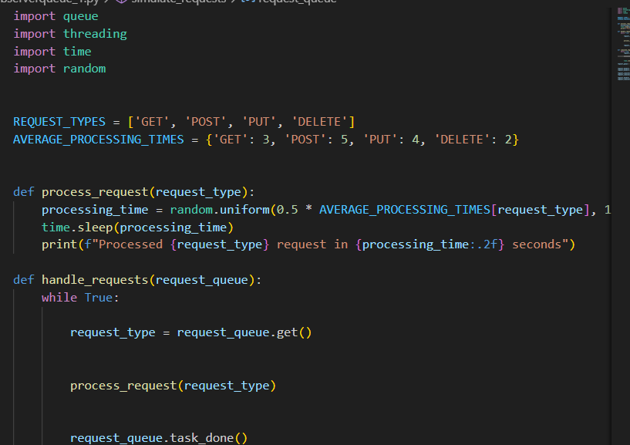

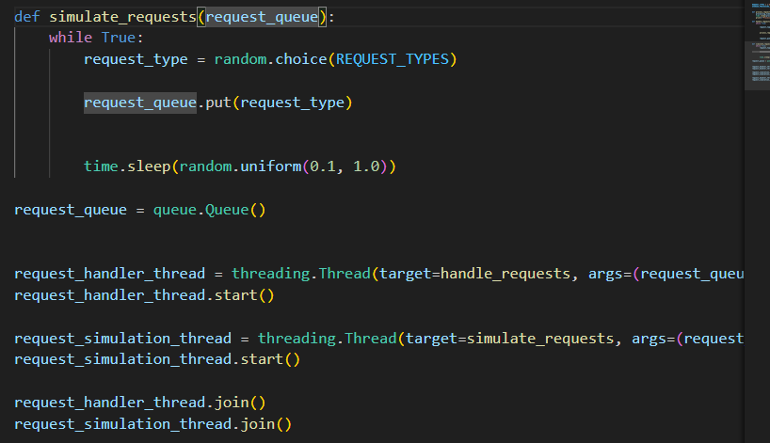

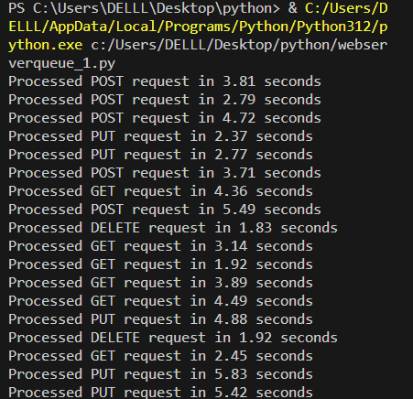

**Q2**

**Linked List Implementation for a Queue:**

1. **Dynamic Size:**
   * **Advantage:** Linked lists allow for dynamic memory allocation, making it easy to accommodate a variable number of elements without the need to preallocate a fixed amount of memory.
   * **Use Case:** When the size of the queue is not known in advance or varies significantly over time.
2. **Constant-Time Insertion and Deletion:**
   * **Advantage:** Insertion and deletion operations at the front and rear of a linked list can be done in constant time (O(1)), assuming you have a reference to the relevant nodes.
   * **Use Case:** In scenarios where fast insertion and deletion at both ends of the queue are critical, especially when the size of the queue is not fixed.
3. **Memory Efficiency:**
   * **Advantage:** Linked lists don't require contiguous memory allocation, making them more memory-efficient if the size of the queue changes frequently.
   * **Use Case:** When memory fragmentation or constraints are a concern, and you want to avoid allocating a large contiguous block of memory.

**Array Implementation for a Queue:**

1. **Random Access:**
   * **Advantage:** Arrays allow for constant-time random access to elements. If you need to access elements at arbitrary positions frequently, an array might be more suitable.
   * **Use Case:** In scenarios where you need to access queue elements at positions other than the front or rear, which is not a typical queue operation.
2. **Cache Locality:**
   * **Advantage:** Arrays offer better cache locality compared to linked lists, as elements are stored in contiguous memory locations. This can lead to better performance in terms of cache usage.
   * **Use Case:** In performance-critical applications where minimizing cache misses is important.
3. **Preallocated Memory:**
   * **Advantage:** If the maximum size of the queue is known in advance and does not change frequently, preallocating an array with a fixed size can be more efficient in terms of memory usage.
   * **Use Case:** In scenarios where memory needs to be managed more predictably, and the size of the queue remains relatively constant.

**Summary:**

* **Linked List:** Dynamic size, frequent insertions/deletions, variable size, memory efficiency.
* **Array:** Random access, cache locality, fixed or known size, better for scenarios with predictable memory requirements.

In practice, the choice often depends on the specific use case and performance requirements of the application. It's essential to consider factors such as the frequency of insertions and deletions, memory constraints, and access patterns when deciding between a linked list and an array implementation for a queue.

**Q3**

**Basic Queue using Arrays:**

1. **Enqueue Operation (push):**
   * **Time Complexity:** O(1) on average.
   * **Explanation:** Appending an element to the end of an array is a constant-time operation. However, in some cases, when the array needs to be resized (e.g., when it reaches its capacity), the time complexity becomes O(n), where n is the number of elements in the array.
2. **Dequeue Operation (pop):**
   * **Time Complexity:** O(n).
   * **Explanation:** Removing an element from the front of an array requires shifting all remaining elements to fill the gap, resulting in a linear time complexity.

**Basic Queue using Linked Lists:**

1. **Enqueue Operation (push):**
   * **Time Complexity:** O(1).
   * **Explanation:** Adding a new element to the end of a linked list involves updating the **next** pointer of the last node to point to the new node. This operation is constant time.
2. **Dequeue Operation (pop):**
   * **Time Complexity:** O(1).
   * **Explanation:** Removing an element from the front of a linked list involves updating the **head** pointer to the next node. This operation is constant time.

**Optimization Strategies:**

1. **Array Implementation:**
   * **Circular Buffer:** To optimize enqueue and avoid frequent resizing, you can use a circular buffer. When the end of the array is reached, new elements can be inserted at the beginning if there is space.
   * **Amortized Resizing:** Resize the array only when it becomes full, and use amortized analysis to show that the average cost per operation remains O(1) over a sequence of operations.
2. **Linked List Implementation:**
   * **Doubly Linked List:** If doubly linked lists are used, dequeuing from the front can be further optimized as it doesn't require traversal from the head.
   * **Memory Pooling:** To minimize memory allocation overhead, consider using memory pooling techniques to reuse nodes.
3. **Hybrid Implementations:**
   * **Combining Arrays and Linked Lists:** In some scenarios, a hybrid approach can be beneficial, using arrays for efficient random access and linked lists for efficient insertions and deletions.
4. **Parallel Processing:**
   * **Lock-Free Queues:** For multithreaded or parallel applications, consider lock-free queue implementations to avoid contention and improve performance.

Choosing the right optimization strategy depends on the specific use case and the nature of the workload. It's important to consider factors such as the frequency of enqueue and dequeue operations, memory constraints, and whether the system is single-threaded or multithreaded.

**Q4**

Using two stacks to implement a queue is a common approach that allows you to simulate a queue using two standard stack data structures. One stack is used for enqueue operations, and the other stack is used for dequeue operations. The basic idea is to reverse the order of elements in one stack when performing enqueue or dequeue operations. Here's a step-by-step explanation:

### Enqueue Operation:

1. **Push the Element onto the Enqueue Stack:**
   * When you want to enqueue an element into the queue, push it onto the stack designated for enqueue operations (let's call it **enqueueStack**).

### Dequeue Operation:

1. **Check if Dequeue Stack is Empty:**
   * If the stack designated for dequeue operations (**dequeueStack**) is empty, transfer all elements from **enqueueStack** to **dequeueStack** to reverse their order.
2. **Pop from Dequeue Stack:**
   * Pop the top element from **dequeueStack** to retrieve the front element of the queue.

### Visualization:

Let's go through an example to illustrate the process:

#### **Enqueue Operations:**

1. Enqueue 1: **enqueueStack = [1]**
2. Enqueue 2: **enqueueStack = [1, 2]**
3. Enqueue 3: **enqueueStack = [1, 2, 3]**

#### **Dequeue Operation:**

1. Dequeue (Front element is 1):
   * **dequeueStack** is empty, so transfer elements from **enqueueStack** to **dequeueStack**:
     + **enqueueStack = []**
     + **dequeueStack = [3, 2, 1]**
   * Pop from **dequeueStack**: Front element is 1.
2. Dequeue (Front element is 2):
   * **dequeueStack** is not empty, so pop from **dequeueStack**: Front element is 2.
3. Dequeue (Front element is 3):
   * **dequeueStack** is not empty, so pop from **dequeueStack**: Front element is 3.

### Python Implementation:

Here's a simple Python implementation:

pythonCopy code

class QueueUsingStacks: def __init__(self): self.enqueue_stack = [] self.dequeue_stack = [] def enqueue(self, item): self.enqueue_stack.append(item) def dequeue(self): if not self.dequeue_stack: # Transfer elements from enqueueStack to dequeueStack to reverse order while self.enqueue_stack: self.dequeue_stack.append(self.enqueue_stack.pop()) if not self.dequeue_stack: # If dequeueStack is still empty, the queue is empty return None return self.dequeue_stack.pop() # Example usage: queue = QueueUsingStacks() queue.enqueue(1) queue.enqueue(2) queue.enqueue(3) print(queue.dequeue()) # Output: 1 print(queue.dequeue()) # Output: 2 print(queue.dequeue()) # Output: 3 print(queue.dequeue()) # Output: None (queue is empty)

This implementation ensures that enqueue and dequeue operations are amortized O(1) in the average case, but the worst-case complexity for dequeue can be O(n) when transferring elements.